Digital Chip Design Program
RTL Design
Alia Alsultan
Elaf Alkhalaf
Lana Aldhali
Manar Alnuqaydan

Task #12
28/07/2026

Controller – Part 1

Task #12.1

12.1.1

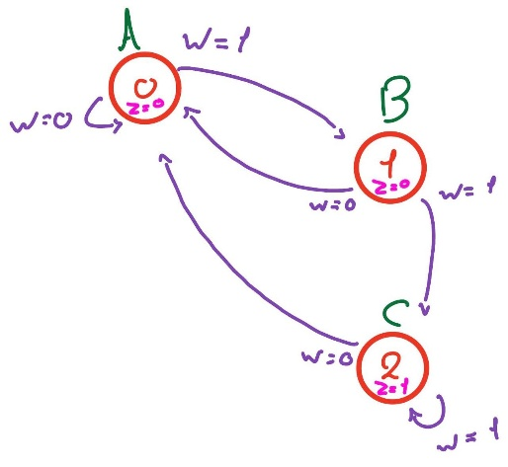

12.1.2

It’s Moore because depend "y " just.

Task #12.2

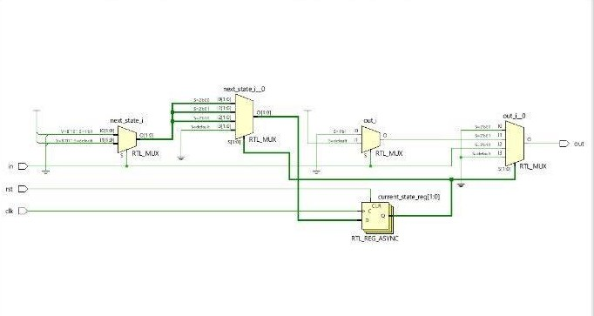

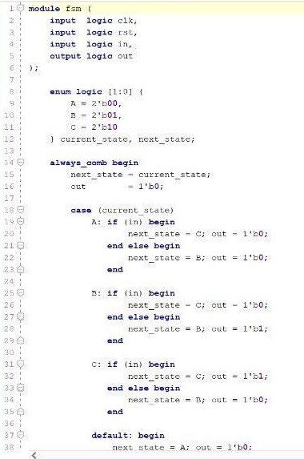

Task #12.3

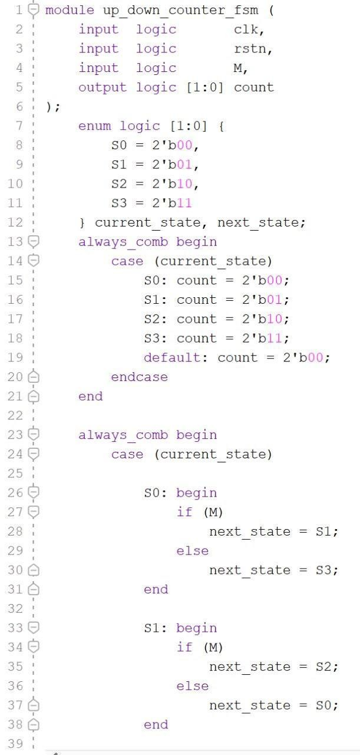

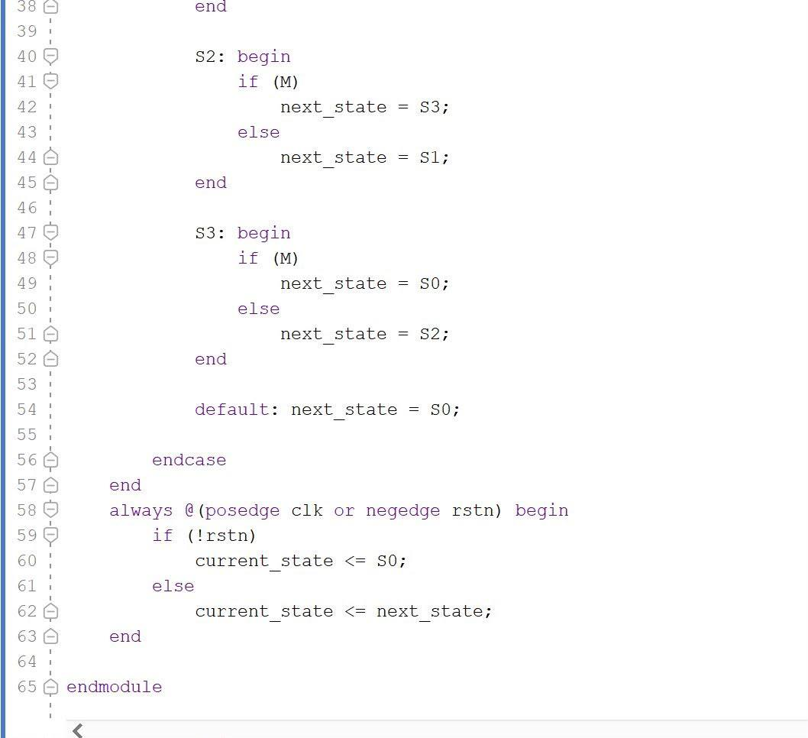

Task #optional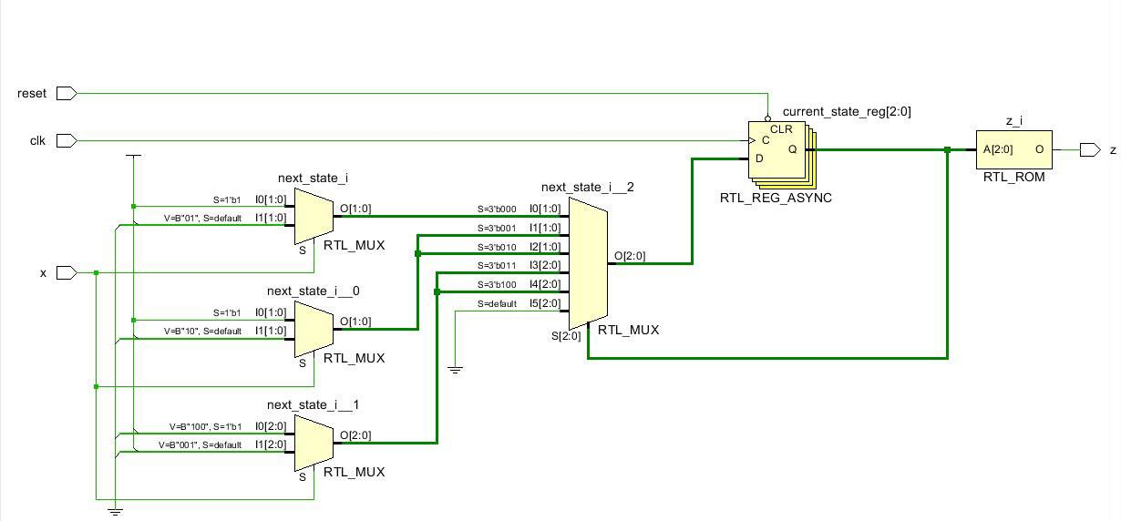

Work distribution

Section | Alia | Elaf | Lana | Manar
Report | ✔ | ✔ | ✔ | ✔
Task 12.1 | ✔ | ✔ | ✔ | ✔
Task 12.2 | ✔ | ✔ | ✔ | ✔
Task 12.3 | ✔ | ✔ | ✔ | ✔
Task Optional | ✔ | ✔ | ✔ | ✔

